Ejemplo RIP
1. router rip
2. version 2
3. network 172.10.0.0
4. network 172.30.0.0
5. network 192.168.10.0
6.

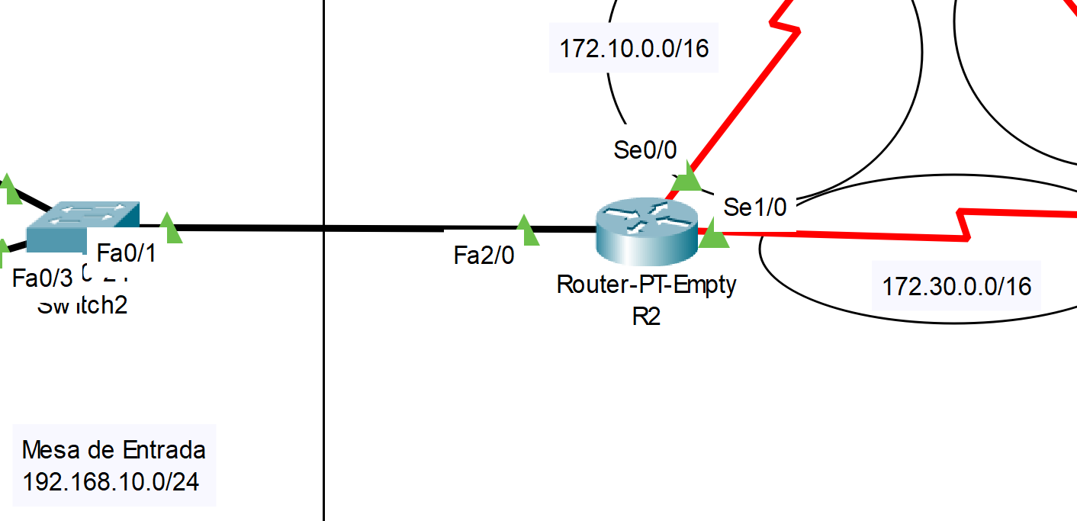

Ejemplo OSPF sin area.
1. router ospf 1
log-adjacency-changes //si hay autenticacion
2. log-adjacency-changes
3. network 192.168.0.0 0.0.0.255 area 0
4. network 192.168.2.0 0.0.0.255 area 0
5. network 192.168.10.0 0.0.0.255 area 0
6. network 192.168.12.0 0.0.0.255 area 0
7.
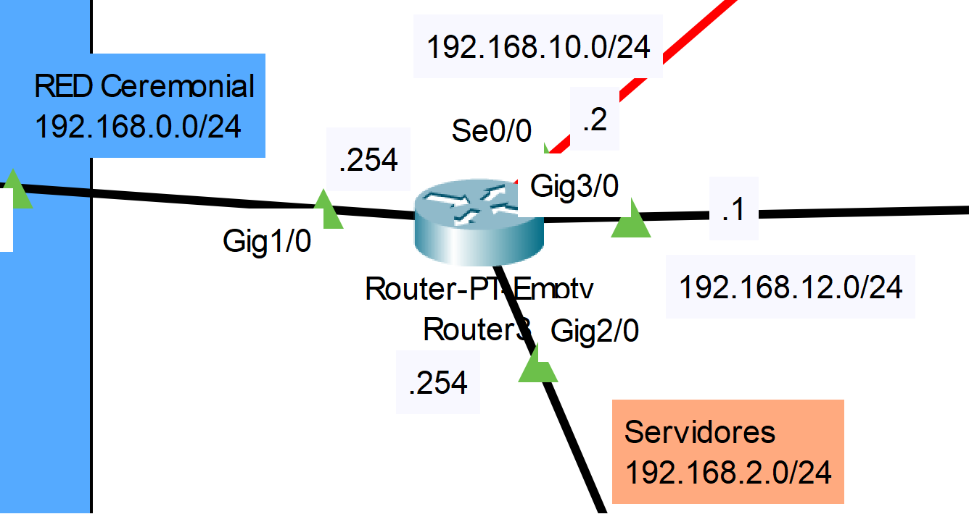
Comando CLI para aplicar Autenticación en OSPFv3:
1. # interface GigabitEthernet1/0
2. # ip ospf authentication message-digest
3. # ip ospf message-digest-key 1 md5 Red3sOSPF
4.

Ospf con areas.
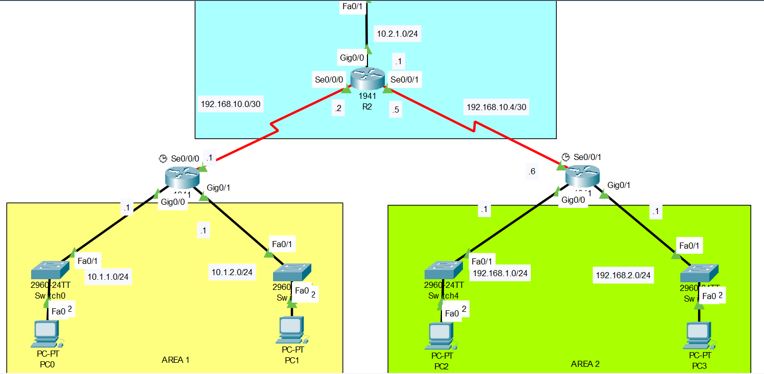
R1
1. router ospf 10
2. router-id 1.1.1.1
3. log-adjacency-changes
4. network 10.1.1.0 0.0.0.255 area 1
5. network 10.1.2.0 0.0.0.255 area 1
6. network 192.168.10.0 0.0.0.3 area 0
7.

R2
1. router ospf 10
2. router-id 2.2.2.2
3. log-adjacency-changes
4. network 192.168.10.0 0.0.0.3 area 0
5. network 192.168.10.4 0.0.0.3 area 0
6. network 10.2.1.0 0.0.0.255 area 0
7.

BGP basico:
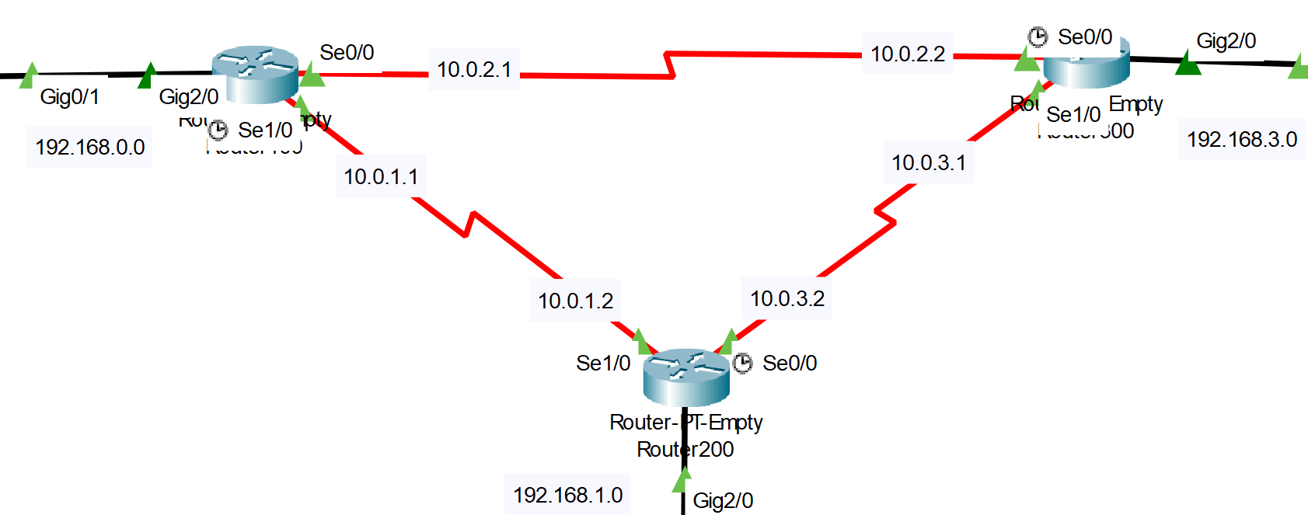
1. router bgp 100
2. neighbor 10.0.1.2 remote-as 200
3. neighbor 10.0.2.2 remote-as 300
4. network 192.168.0.0
5.
6. router bgp 200
7. neighbor 10.0.1.1 remote-as 100
8. neighbor 10.0.3.1 remote-as 300
9. network 192.168.1.0
10.
11. router bgp 300
12. neighbor 10.0.2.1 remote-as 100
13. neighbor 10.0.3.2 remote-as 200
14. network 192.168.3.0
15.

BGP + OSPF
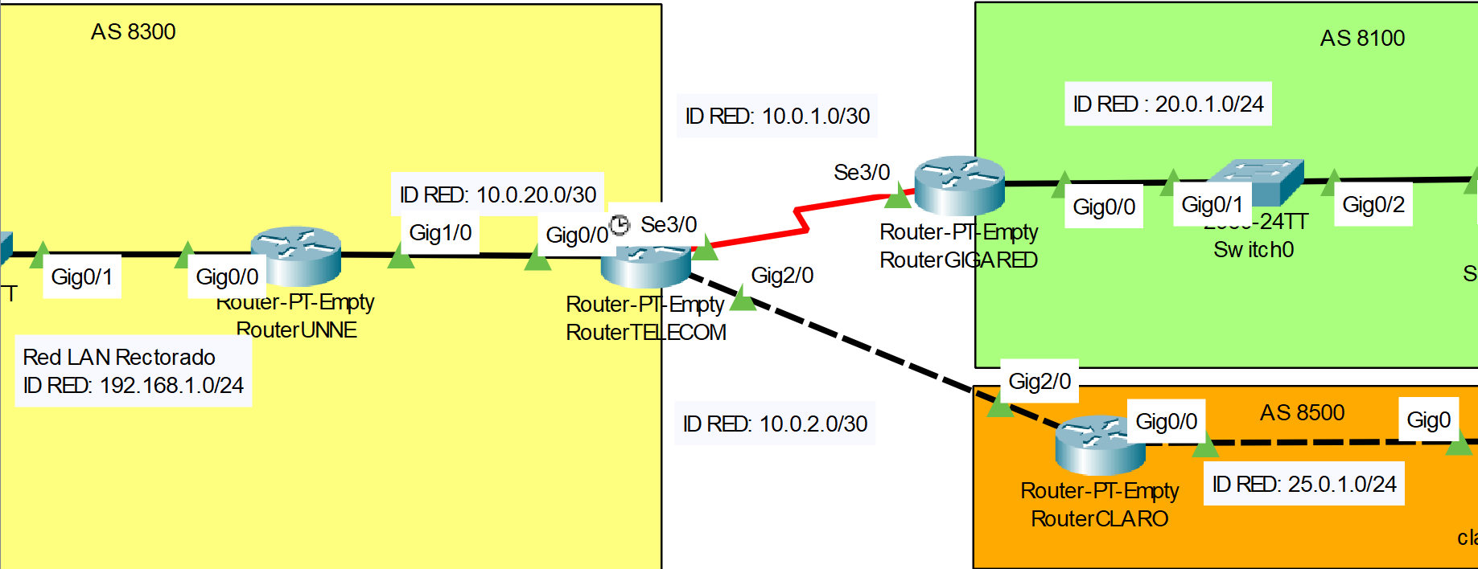
RouterUNNE
1. router ospf 64512
2. network 192.168.1.0 0.0.0.255 area 0
3. network 10.0.20.0 0.0.0.3 area 0
4.
5. ip route 0.0.0.0 0.0.0.0 GigabitEthernet1/0

RouterTELECOM
1. router ospf 64512
2. network 10.0.20.0 0.0.0.3 area 0
3.
4. router bgp 8300
5. neighbor 10.0.1.2 remote-as 8100
6. neighbor 10.0.2.2 remote-as 8500
7. network 192.168.1.0
8.
RouterGIGARED
1. router bgp 8100
2. neighbor 10.0.1.1 remote-as 8300
3. network 20.0.1.0 mask 255.255.255.0
4.
RouterCLARO
1. router bgp 8500
2. neighbor 10.0.2.1 remote-as 8300
3. network 25.0.1.0 mask 255.255.255.0
4.

VLAN
1. vlan 10
2. name datacenter
3. vlan 50
4. name administracion
5. vlan 100
6. name gerencia
7. vlan 200
8. name invitados
9. vlan 300
10. name infraestructura
11. vlan 400
12. name sistemas
13. vlan 500
14. name deposito
15. vlan 600
16. name test
17.

1. router 0
2. ip dhcp excluded-address 192.168.10.1 192.168.10.99
3. ip dhcp excluded-address 192.168.50.1 192.168.50.99
4. ip dhcp excluded-address 192.168.20.1 192.168.20.99
5. ip dhcp excluded-address 192.168.30.1 192.168.30.99
6. ip dhcp excluded-address 192.168.40.1 192.168.40.99
7. ip dhcp excluded-address 192.168.60.1 192.168.60.99
8. ip dhcp excluded-address 192.168.55.1 192.168.55.99
9. ip dhcp excluded-address 192.168.100.1 192.168.100.99
10.
11. ip dhcp pool 10
12. network 192.168.10.0 255.255.255.0
13. default-router 192.168.10.1
14. dns-server 172.16.10.100
15. ip dhcp pool 50
16. network 192.168.50.0 255.255.255.0
17. default-router 192.168.50.1
18. dns-server 172.16.10.100
19. ip dhcp pool 100
20. network 192.168.100.0 255.255.255.0
21. default-router 192.168.100.1
22. dns-server 172.16.10.100
23. ip dhcp pool 200
24. network 192.168.20.0 255.255.255.0
25. default-router 192.168.20.1
26. dns-server 172.16.10.100
27. ip dhcp pool 300
28. network 192.168.30.0 255.255.255.0
29. default-router 192.168.30.1
30. dns-server 172.16.10.100
31. ip dhcp pool 400
32. network 192.168.40.0 255.255.255.0
33. default-router 192.168.40.1
34. dns-server 172.16.10.100
35. ip dhcp pool 500
36. network 192.168.55.0 255.255.255.0
37. default-router 192.168.55.1
38. dns-server 172.16.10.100
39. ip dhcp pool 600
40. network 192.168.60.0 255.255.255.0
41. default-router 192.168.60.1
42. dns-server 172.16.10.100
43.
44. interface GigabitEthernet0/0
45. no ip address
46. duplex auto
47. speed auto
48.
49. interface GigabitEthernet0/0.10
50. encapsulation dot1Q 10
51. ip address 192.168.10.1 255.255.255.0
52.
53. interface GigabitEthernet0/0.50
54. encapsulation dot1Q 50
55. ip address 192.168.50.1 255.255.255.0
56.
57. interface GigabitEthernet0/0.100
58. encapsulation dot1Q 100
59. ip address 192.168.100.1 255.255.255.0
60.
61. interface GigabitEthernet0/0.200
62. encapsulation dot1Q 200
63. ip address 192.168.20.1 255.255.255.0
64.
65. interface GigabitEthernet0/0.300
66. encapsulation dot1Q 300
67. ip address 192.168.30.1 255.255.255.0
68.
69. interface GigabitEthernet0/0.400
70. encapsulation dot1Q 400
71. ip address 192.168.40.1 255.255.255.0
72.
73. interface GigabitEthernet0/0.500
74. encapsulation dot1Q 500
75. ip address 192.168.55.1 255.255.255.0
76.
77. interface GigabitEthernet0/0.600
78. encapsulation dot1Q 600
79. ip address 192.168.60.1 255.255.255.0
80.
81. interface Serial1/0
82. ip address 10.0.1.1 255.255.255.0
83.
84. ip route 0.0.0.0 0.0.0.0 Serial1/0
85.

